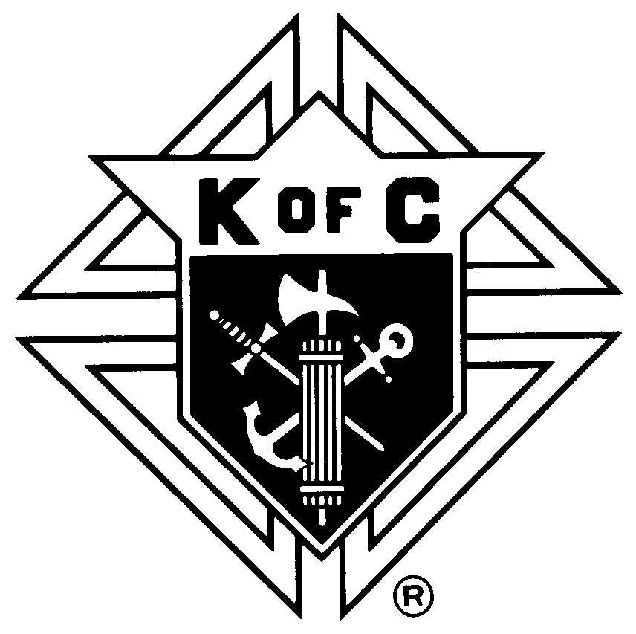
Knights of Columbus
Oklahoma State Council

Initiation Fees
2012-2013 Fraternal Year

Initiation Fees for new members should be remitted to the State Secretary immediately following the exemplification of the First Degree of the Order. These funds are used to reimburse the Major Degree Team for their expenses and $5 is paid to the council hosting the degree to pay for the candidate's meal.

Council No: |  | Date:

 |  | No. of New  Members |  | Fee |  |  | Sub-Total
Age 27 or older |  |  |  | $10.00
Age 26 or younger |  |  |  | $5.00
On Active Military Duty |  |  |  | $5.00
 |  |  | Total: |  | $

Remit to: K of C Oklahoma State Council
Ron Schwarz
State Secretary
PO Box 5236
Edmond, OK 73083

